
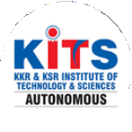
KKR & KSR Institute of Technology and Sciences
(Autonomous)
Approved by AICTE, New Delhi and Permanently Affiliated to JNTUK, Kakinada
Accredited by NBA-Tier-I(WA) & NAAC with Grade ‘A’.

KITS ACM STUDENT CHAPTER

ACM DSP PROGRAMME

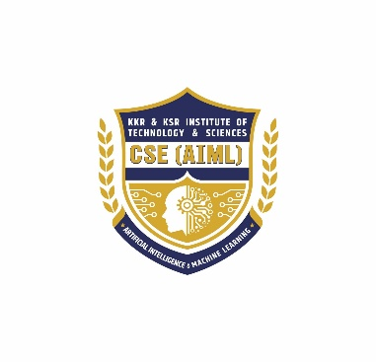
Date : 27.02.2026 Venue: Sir C.V.Raman Hall

Organized by
DEPARTMENT OF CSE (AI & ML)
Distinguished Speaker Programme
Topic : Demystifying Quantum Computing Technology
ESP Speaker : Dr. Ashwani Kumar Cherukuri
Organised by : KITS ACM Student Chapter, Department of
CSE(AI& ML)
Host Institution : KKR & KSR Institute of Technology and Sciences –
(AUTONOMOUS)
Number of ACM Students attended: 18

Number of Professional Members attended: 3
Number of students attended : 407
The KITS ACM Student Chapter successfully organized a Distinguished Speaker Programme on 27th February 2026 with the objective of enriching students’ knowledge and exposing them to emerging trends in the field of computing and technology.
The event commenced with a warm welcome to the distinguished speaker, faculty members, and students. The programme witnessed enthusiastic participation from students of various departments, particularly from Computer Science and related disciplines.
The invited speaker, Dr.Aswani Kumar Cherukuri an eminent expert in the field, delivered an insightful talk on contemporary advancements and real-world applications in computing. The session covered key topics such as recent technological innovations, industry expectations, research opportunities, and career guidance. The speaker also shared valuable personal experiences, motivating students to pursue excellence in both academic and professional domains.
One of the highlights of the programme was the interactive session, where students actively engaged with the speaker by asking thoughtful questions. The speaker addressed these queries with clarity, providing practical insights and guidance.
The programme served as a significant platform for students to gain exposure to industry perspectives and current research trends. It helped bridge the gap between academic learning and real-world applications.
The event concluded with a vote of thanks, expressing gratitude to the speaker for their valuable time and knowledge sharing, as well as to the organizing team and participants for making the programme a success.
Overall, the Distinguished Speaker Programme was highly informative, inspiring, and beneficial for all attendees.
Objectives
• To provide students with exposure to recent advancements and emerging trends in the field
of quantum computing.
• To bridge the gap between academic learning and industry practices
• To offer insights into career opportunities, higher studies, and research directions
• To enable interaction between students and experienced professionals/experts
• To motivate students to enhance their technical knowledge, skills, and innovation
capabilities
• To create awareness about real-world applications of theoretical concepts
• To encourage students to actively participate in professional bodies like ACM and similar
technical communities
• To develop a platform for knowledge sharing and intellectual discussion
Programme schedule
10:00 a.m. – 10:05 a.m - Welcome and Invocation
10:05 a.m. – 10:10 a.m - Welcome Address by Master of Ceremony
10:10 a.m. – 10:15 a.m. - Calling the Dignitaries onto the Dais-
Dr. S. Radha Krishnan Sir, Hod Sir, Principal Sir, and Resource Person.
10:30 a.m. – 10:40 a.m. - Introduction and Profile of Resource Person Dr. Aswani Kumar
Cherukuri.
10:40 a.m. – 11:40 a.m. - Technical Talk by Resource Person Dr. Aswani Kumar
Cherukuri.
11:40 a.m. – 11:55 a.m. - Speech by Director Sir
11:55 a.m. – 12:10 p.m. - Felicitation to Chief Guest by Director Sir
12:10 p.m. – 12:20 p.m. - Vote of Thanks
12:20 p.m. – 12:30 p.m. - Closing with National Anthem.
Target audience:
Undergraduate students of CSE-AIML and allied branches, faculty members, research scholars.
Career & research directions:
- Opportunities in Quantum Computing and applications that can be developed using quantum computing.
- Recommended starting projects in quantum computing and learning resources (practical labs, datasets, conferences).

Closing & Felicitation Ceremony:
The program concluded with a felicitation ceremony. The Director of KKR & KSR Institute of Technology and Sciences, Dr. K. Hari Babu Garu, graced the occasion and felicitated Dr. Aswani Kumar Cherukuri with a memento and shawl as a token of appreciation for sharing his valuable knowledge and expertise.

In his address, Dr. K. Hari Babu Garu congratulated the CSE–AIML Department and the KITS ACM Student Chapter for organizing such a meaningful and technically enriching event. He emphasized the importance of continuous learning and urged students to adapt to evolving technologies responsibly.

The session concluded with a formal vote of thanks proposed by the faculty coordinator, appreciating the management, speaker, faculty, and students for their active participation and support.

Outcomes of the Programme:
- Enhanced understanding of current trends and advancements in quantum computing
- Increased awareness of industry expectations and career opportunities
- Motivation among students to pursue higher studies and research
- Improved interaction between students and experts from the field
- Strengthening of the ACM Student Chapter’s academic activities

Feedback Analysis:
Feedback was collected from participants to evaluate the effectiveness of the programme. The overall response was highly positive.
- Content Quality: Participants appreciated the relevance and depth of the topics covered
- Speaker Effectiveness: The speaker was highly rated for clarity, knowledge, and presentation skills
- Engagement Level: Students found the session interactive and engaging
- Usefulness: Majority of attendees reported that the programme was beneficial for their academic and career growth
Overall Rating:
The programme received an average rating of 4.5/5, indicating a high level of satisfaction among participants.
Photos:
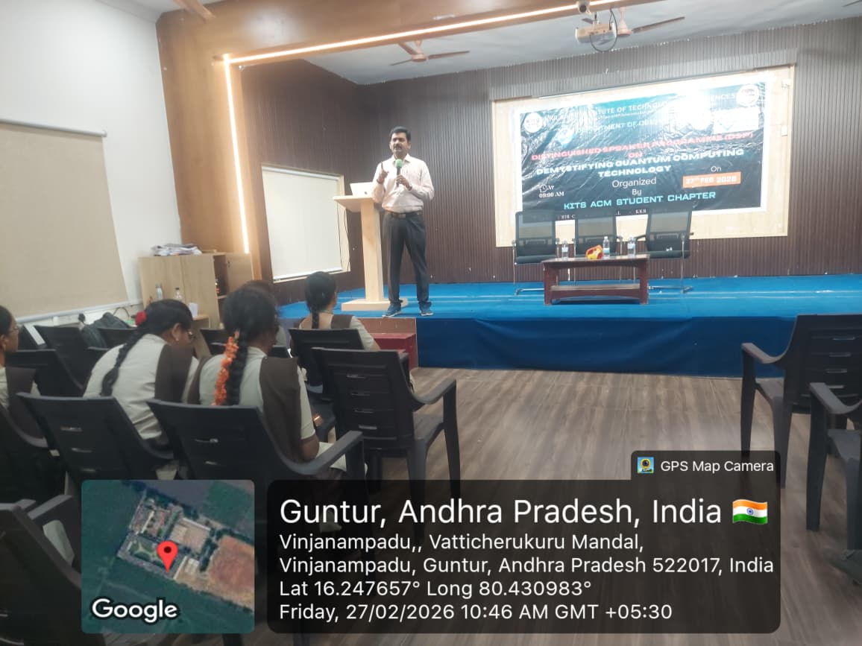 | 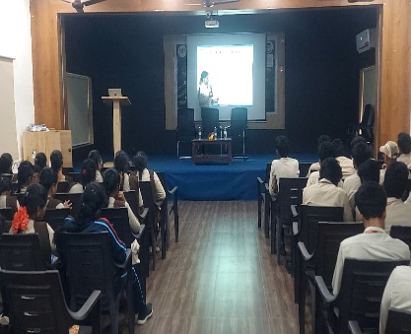
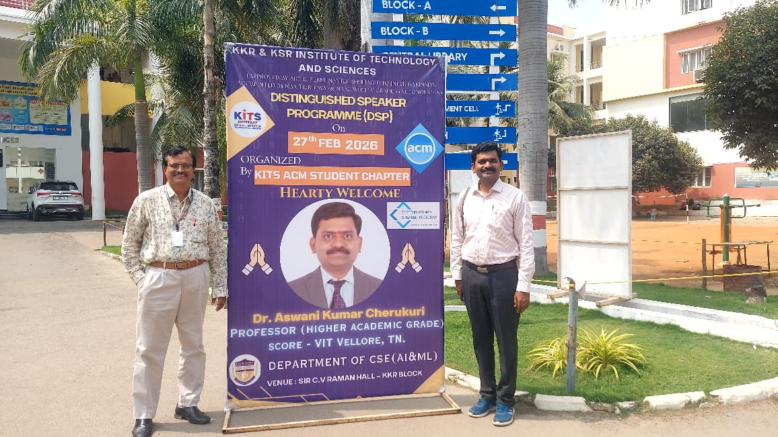 | 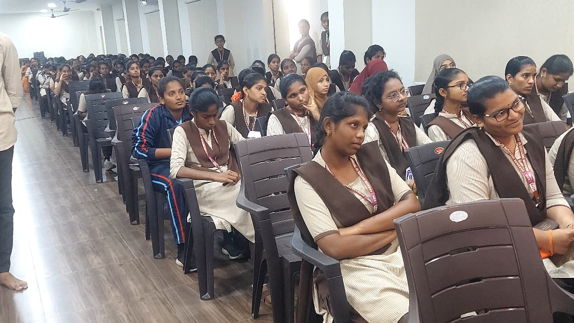
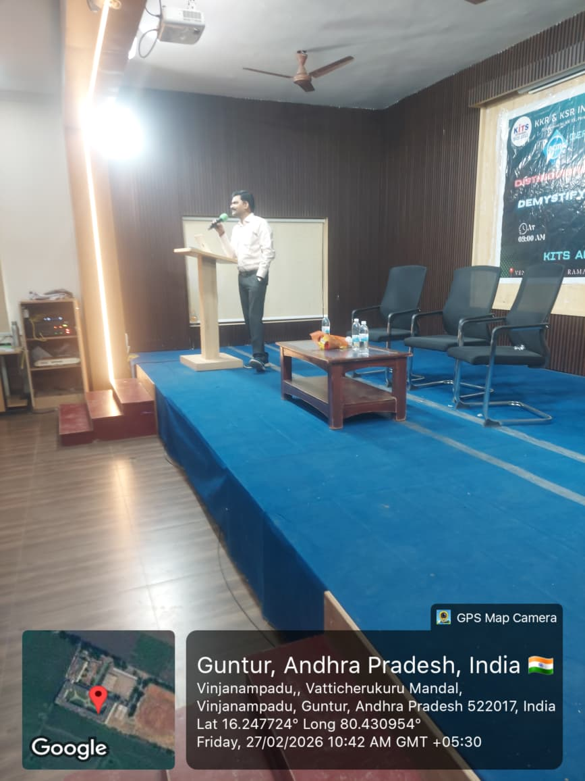 | 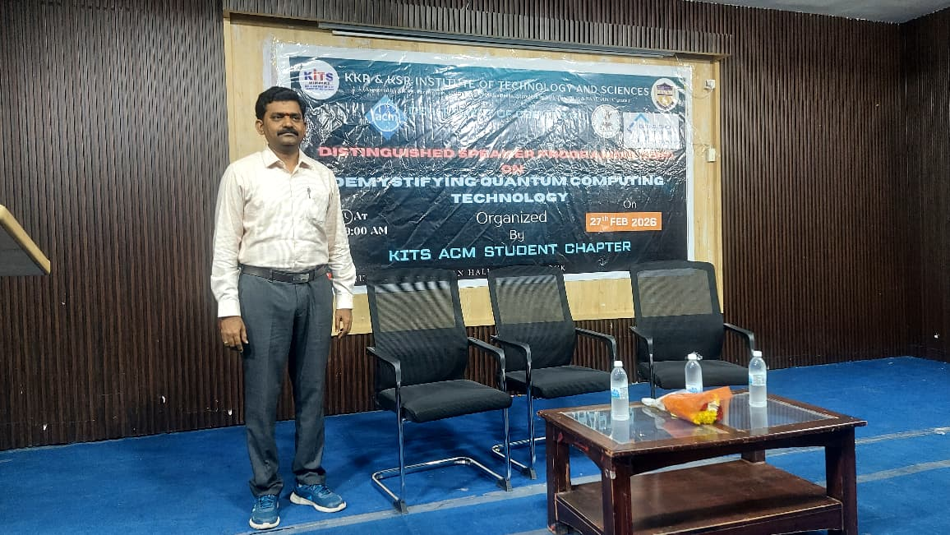
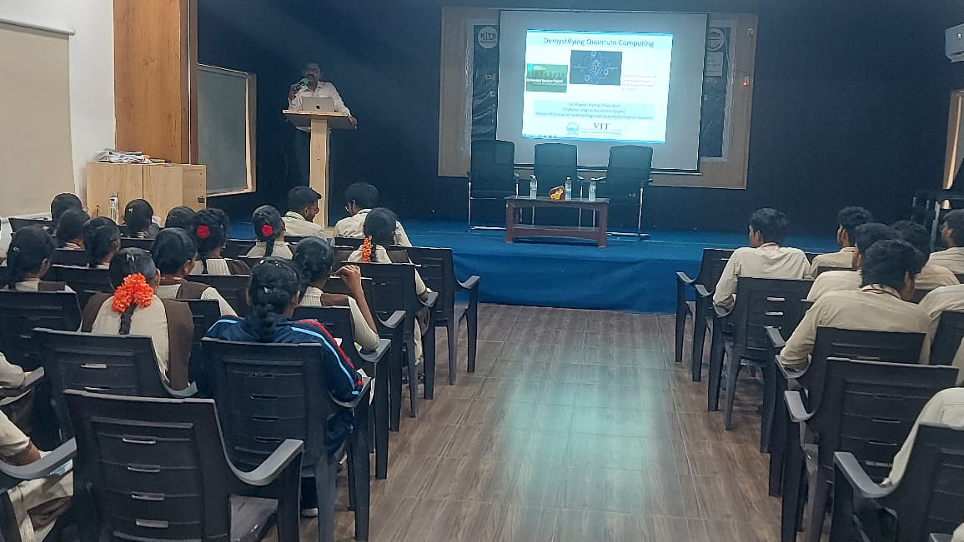 | 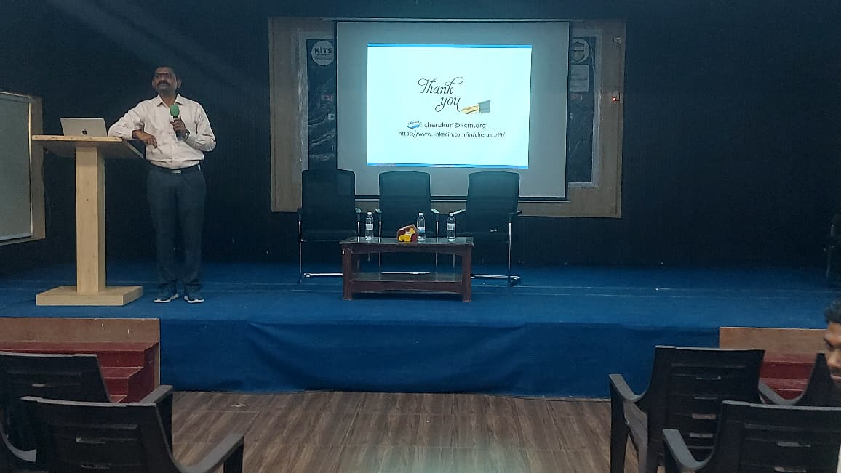
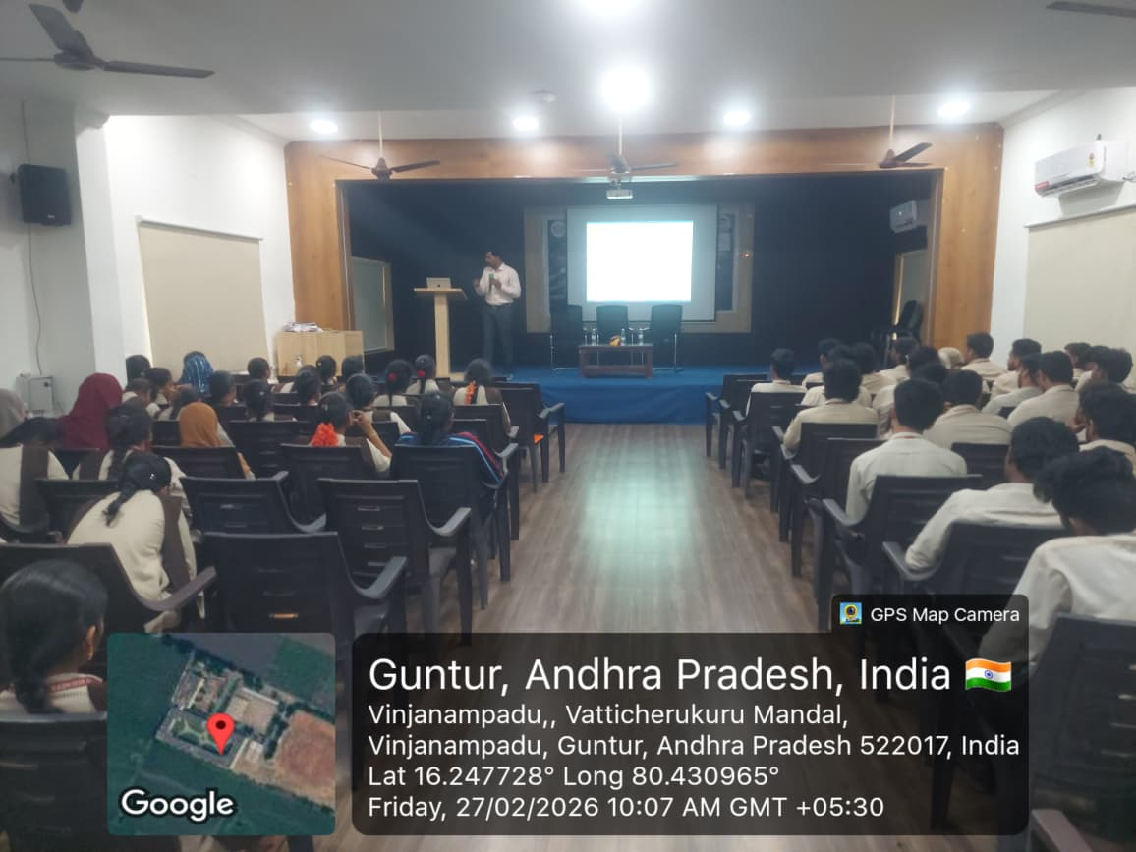 | 