
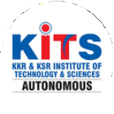
KKR & KSR Institute of Technology and Sciences
(Autonomous)
Approved by AICTE, New Delhi and Permanently Affiliated to JNTUK, Kakinada
Accredited by NBA-Tier-I(WA) & NAAC with Grade ‘A’.

KITS ACM STUDENT CHAPTER

ACM ESP PROGRAMME

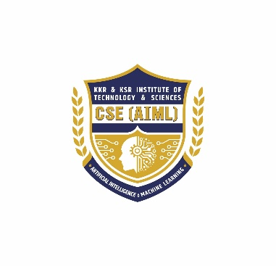
Date : 22.10.2025 Venue: Sir C.V.Raman Hall

Organized by
DEPARTMENT OF CSE (AI & ML)
Eminent Speaker Programme
Topic : Applications of Gen-AI in Cybersecurity
ESP Speaker : Dr. Gururaj H.L. Garu
Organised by : KITS ACM Student Chapter, Department of
CSE(AIML)
Host Institution : KKR & KSR Institute of Technology and Sciences –
(AUTONOMOUS)
Number of ACM Students attended: 15

Number of Professional Members attended: 3
Number of students attended : 300
On 22 October 2025, the KITS ACM Student Chapter (Department of CSE–AIML) successfully organized an Eminent Speaker Programme featuring Dr. Gururaj H.L. garu on Generative AI & Cyber Security. The session brought together students, faculty, and invited guests to explore intersections between large generative models and security — covering practical risks, mitigation strategies, and career pathways. The event combined a keynote lecture, live demos / case studies, Q&A, and interactive discussion. Attendance was strong and feedback was highly positive.
Objectives
- Introduce students and faculty to the fundamentals and recent advances in generative AI.
- Highlight cyber security risks introduced by generative models (e.g., prompt-based attacks, synthetic media / deepfakes, automated vulnerability discovery).
- Share best practices and mitigation strategies for securing AI systems.
- Inspire students to pursue research or careers at the intersection of AI and security.
- Strengthen the KITS ACM Student Chapter’s outreach and industry/academic linkages.
Programme schedule
09:30 – 10:00 Registration & Welcome Tea
10:00 – 10:15 Opening remarks — Convener / HOD, CSE–AIML
10:15 – 11:30 Keynote Lecture by Dr. Gururaj H.L. garu: Generative AI & Cyber Security
11:30 – 12:00 Live demonstrations / Case studies
12:00 – 12:40 Interactive Q&A with participants
12:40 – 12:50 Vote of thanks & closing remarks
12:50 – 13:30 Networking / Photo session
Target audience:
Undergraduate students of CSE-AIML and allied branches, faculty members, research scholars.
Opening:
Dr. Gururaj opened with a concise history of generative AI — from probabilistic generative models to modern transformer-based large language and diffusion models and contextualized why the topic matters for security practitioners and researchers.
Technical overview:
- Architecture and functioning of modern generative models (high level).
- Capabilities: text generation, code generation, image/video/audio synthesis.
- Examples of real-world uses and productivity gains.
Security risks discussed:
- Misinformation & deepfakes: Societal and organizational impacts of convincingly synthetic media.
- Model misuse: Social engineering, automated spear-phishing, disinformation campaigns.
- Adversarial & prompt attacks: Data poisoning, model inversion, prompt injection vulnerabilities.
- Automated vulnerability discovery: How code-generating models can accelerate both defensive and offensive discovery.
- Privacy leakage: Risk of training data exposure and membership inference.
Mitigation & best practices:
- Rigorous model governance: model cards, data provenance, access controls.
- Robust prompt/interaction design and input sanitization to reduce prompt injection.
- Monitoring, anomaly detection, watermarking synthetic content, and provenance tracking.
- Multi-layered defenses: combining technical, policy, and human review processes.
- Responsible disclosure, red teaming, and continuous adversarial testing during model development and deployment.
Career & research directions:
- Opportunities in AI-security research, secure MLOps, incident response for AI systems, and policy/ethics roles.
- Recommended starting projects and learning resources (practical labs, datasets, conferences).

Closing & Felicitation Ceremony:
The program concluded with a felicitation ceremony. The Director of KKR & KSR Institute of Technology and Sciences, Dr. K. Hari Babu Garu, graced the occasion and felicitated Dr. Gururaj H. L. Garu with a memento and shawl as a token of appreciation for sharing his valuable knowledge and expertise.

In his address, Dr. K. Hari Babu Garu congratulated the CSE–AIML Department and the KITS ACM Student Chapter for organizing such a meaningful and technically enriching event. He emphasized the importance of continuous learning and urged students to adapt to evolving technologies responsibly.

The session concluded with a formal vote of thanks proposed by the faculty coordinator, appreciating the management, speaker, faculty, and students for their active participation and support.

Outcomes of the Programme:

- Enhanced Technical Knowledge:

Participants gained in-depth understanding of Generative Artificial Intelligence concepts and the critical role of Cyber Security in protecting AI-driven systems.

- Awareness of Emerging Threats:
The session enlightened students on the latest AI-related security challenges such as data leakage, deepfakes, prompt injection attacks, and model vulnerabilities.
- Bridging Theory and Practice:
Through real-world examples and case studies shared by Dr. Gururaj H. L. Garu, participants learned how AI can both strengthen and compromise digital security systems.
- Inspiration for Research and Innovation:
The talk motivated students to take up AI-Security-based research projects, internships, and innovative solutions addressing current cyber challenges.
- Professional Development:
Students were encouraged to develop ethical and responsible AI practices, preparing them for future roles in AI development, data protection, and information security.
- Increased Engagement in ACM Activities:
The programme successfully promoted the KITS ACM Student Chapter, encouraging more students to participate in upcoming workshops, hackathons, and technical events.
- Institutional Growth:
The event strengthened the department’s reputation for promoting industry-relevant learning and fostering collaborations between academia and experts in emerging technologies.

Photographic Highlights of Eminent Speaker Programme on “Generative AI & Cyber Security”
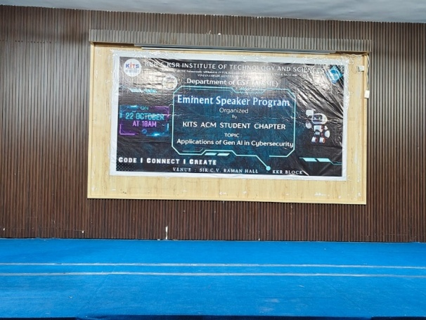 | 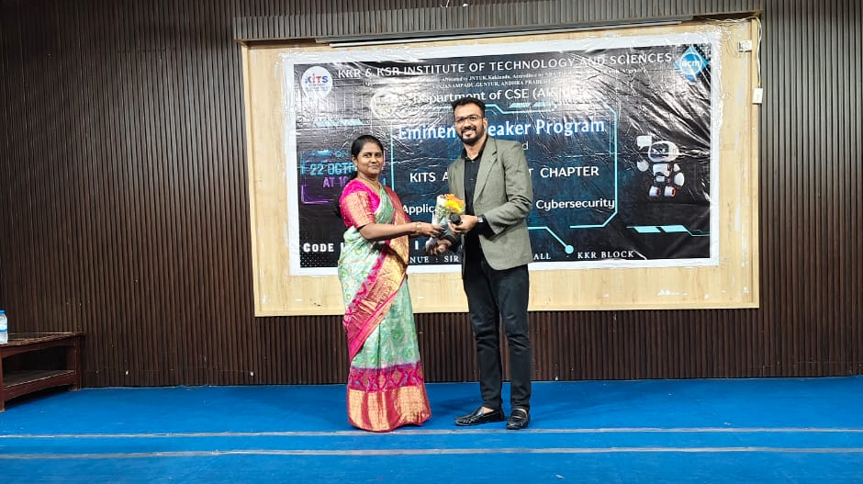
Event Banner Display | Welcoming the Chief Guest – Dr. Gururaj H. L. Garu
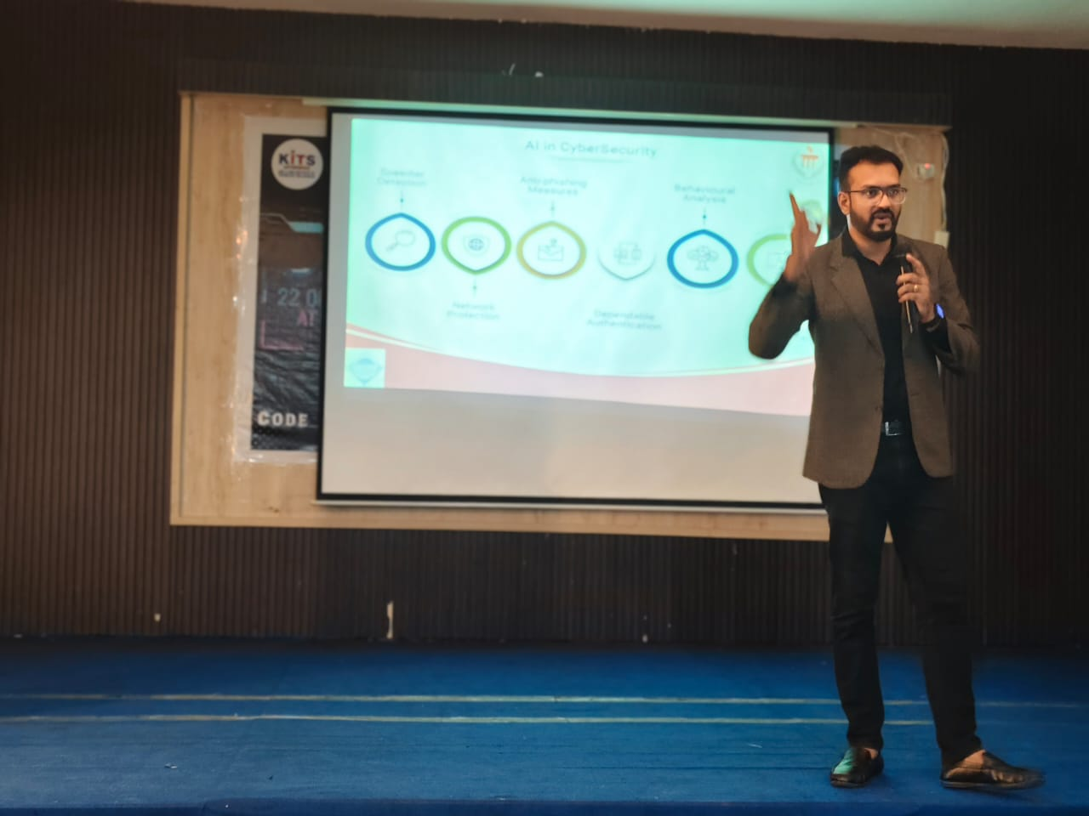 | 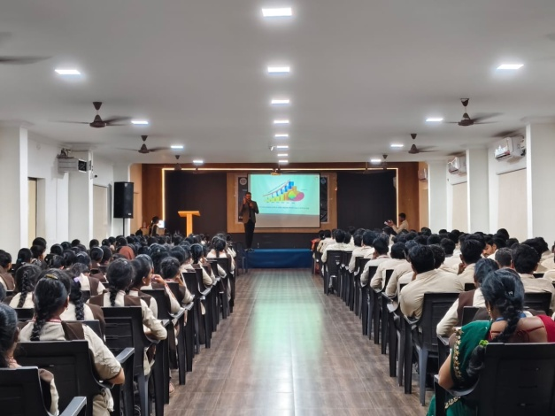
Keynote Session by Dr. Gururaj H.L Garu | Audience Listening to the Expert Talk
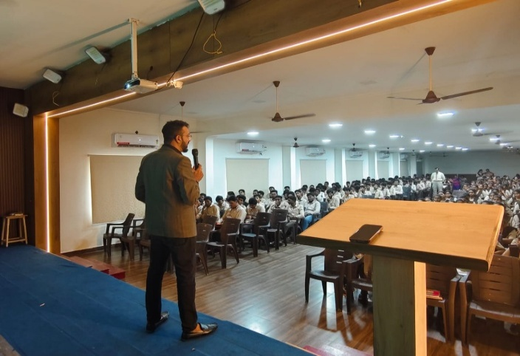 | 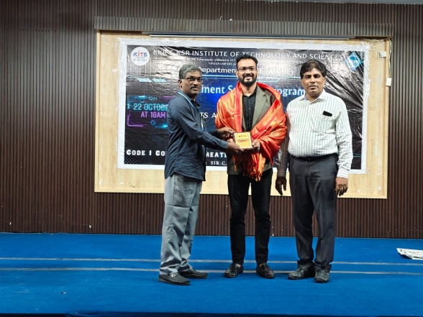
- Interactive Session with Students | - Felicitation by Director Sir Dr. K. Hari Babu Garu

