
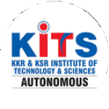
KKR & KSR Institute of Technology and Sciences
(Autonomous)
Approved by AICTE, New Delhi and Permanently Affiliated to JNTUK, Kakinada
Accredited by NBA-Tier-I(WA) & NAAC with Grade ‘A’.

KITS ACM STUDENT CHAPTER

INNOVATION DAY

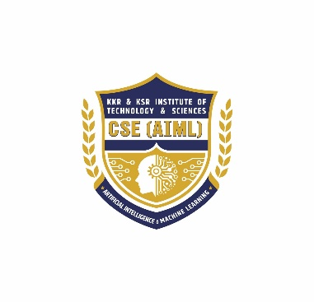
Date : 15.10.2025 Venue: Sir C.V.Raman Hall

Organized by
DEPARTMENT OF CSE (AI & ML)
Innovation Day
Topic : Innovation Day
Organised by : KITS ACM Student Chapter, Department of
CSE(AIML)
Host Institution : KKR & KSR Institute of Technology and Sciences –
(AUTONOMOUS)
Number of ACM Students attended: 15

Number of Professional Members attended: 3
Number of students attended : 204
On 15 October 2025, the KITS ACM Student Chapter (Department of CSE–AIML) successfully organized an Innovation Day on the birth anniversary of Dr APJ Abdul Kalam Garu. Innovation Day was organized with the objective of encouraging young innovators, promoting creative thinking, and providing a platform for students to present their unique ideas and solutions. The event focused on transforming imagination into practical concepts through structured presentations, idea pitching, and interactive sessions with the review panel.

Objectives
- To encourage students to showcase innovative thinking and technical creativity
- To help students convert ideas into executable projects
- To develop entrepreneurial mindsets and problem-solving abilities
- To provide expert feedback and guidance to student innovators
- To identify promising ideas for incubation and prototype development
Programme schedule:
10:00 AM – 10:15 AM: Inauguration & Welcome Address by HOD / Convener
10:15 AM – 10:30 AM: Event Overview & Instructions for Idea Presentations
10:30 AM – 12:45 PM: Session I – Idea Presentations (Batch 1) Team Presentations + Q&A with Panel
12:45 PM – 01:00 PM: Panel Interaction & Suggestions
01:00 PM – 02:00 PM: Lunch Break
02:00 PM – 04:00 PM: Session II – Idea Presentations (Batch 2)Team Presentations + Q&A with Panel
04:00 PM – 04:20 PM: Panel Feedback & Discussion
04:20 PM – 04:45 PM: Results Announcement & Award Distribution
04:45 PM – 05:00 PM: Vote of Thanks & Group Photo Session
Target audience:
Undergraduate students of CSE-AIML and allied branches, faculty members, research scholars.
Opening:
The event began with the HOD’s opening address, highlighting the purpose of Innovation Day — encouraging creative thinking, nurturing problem-solving skills, and inspiring students to transform their ideas into meaningful solutions with real-world impact.
Technical overview:
- Idea Structure: Teams presented their problem statement, solution approach, and basic system design.
- Core Capabilities: Solutions showcased automation, AI/ML features, IoT integration, and user-focused applications.
- Use Cases & Impact: Each idea highlighted real-world applications and how it improves efficiency and productivity.
Security risks discussed:
• Technical Limitations:
Teams identified challenges such as data scarcity, integration issues, and prototype feasibility.
• Security Concerns:
Ideas addressed risks like data privacy, unauthorized access, and safe handling of user information.
• Implementation Barriers:
Participants highlighted constraints in funding, real-world deployment, and scalability.

Mitigation & best practices:
- Secure Design Approach: Teams recommended privacy-focused architecture and safe data handling from the design stage.
- Access Control & Authentication: Use of proper authorization, encrypted storage, and strong authentication methods.
- Regular Testing & Updates: Continuous testing, security audits, and timely updates to prevent vulnerabilities.
- User Awareness: Promoting safe usage practices and clear guidelines for end users.
Career & research directions:
• Innovation-Based Roles: Opportunities in product development, startup incubation, and technology innovation.
• Research Pathways: Scope for academic and applied research in AI/ML, IoT systems, smart solutions, and sustainable tech.
• Interdisciplinary Projects: Encouragement to work across domains like healthcare, agriculture and cybersecurity.

Closing & Felicitation Ceremony:
The program concluded with a felicitation ceremony. The Director of KKR & KSR Institute of Technology and Sciences, Dr. K. Hari Babu Garu, graced the occasion and felicitated G. Bharath Kumar Garu and Raju Mithra Kantheti Garu with a memento and shawl as a token of appreciation for sharing his valuable knowledge and expertise.

In his address, Dr. K. Hari Babu Garu congratulated the CSE–AIML Department and the KITS ACM Student Chapter for organizing such a meaningful and technically enriching event. He emphasized the importance of continuous learning and urged students to adapt to evolving technologies responsibly.

The session concluded with a formal vote of thanks proposed by the faculty coordinator, appreciating the management, faculty, and students for their active participation and support.

Outcomes of the Programme:
• Enhanced Innovative Thinking: Students gained confidence to explore creative ideas and propose practical solutions.
• Real-World Problem Understanding: Teams developed pitching, communication, and project explanation skills through idea showcasing.
• Collaborative Learning: The event promoted teamwork, knowledge sharing, and interdisciplinary collaboration.
• Expert Feedback & Guidance: Students received valuable suggestions from faculty and reviewers to refine and improve their ideas.
• Identification of Promising Projects: Select ideas were shortlisted for further development, mentoring, and possible incubation.

INNOVATION DAY- 15.10.25
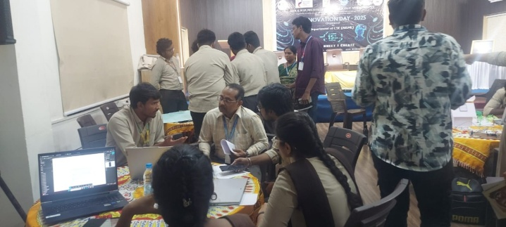 | 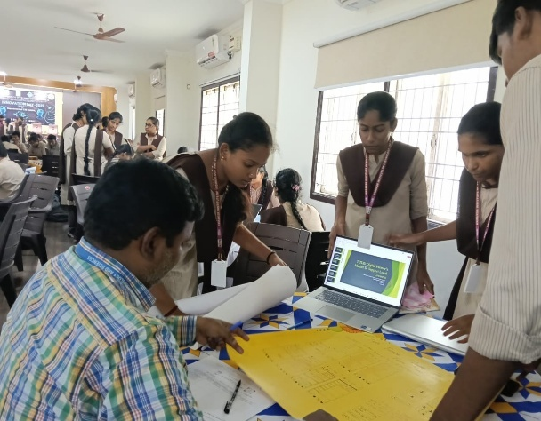
Collaborative Brainstorming at the Innovation Hub | Student Team Presenting Their Prototype to the Panel”
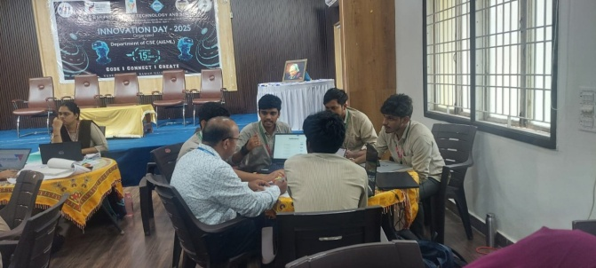 | 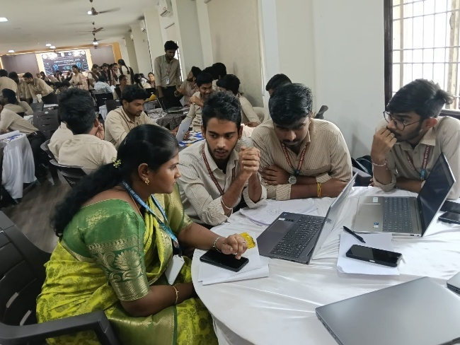
Idea Evaluation Session with Mentors | Active Team Discussion During Project Development
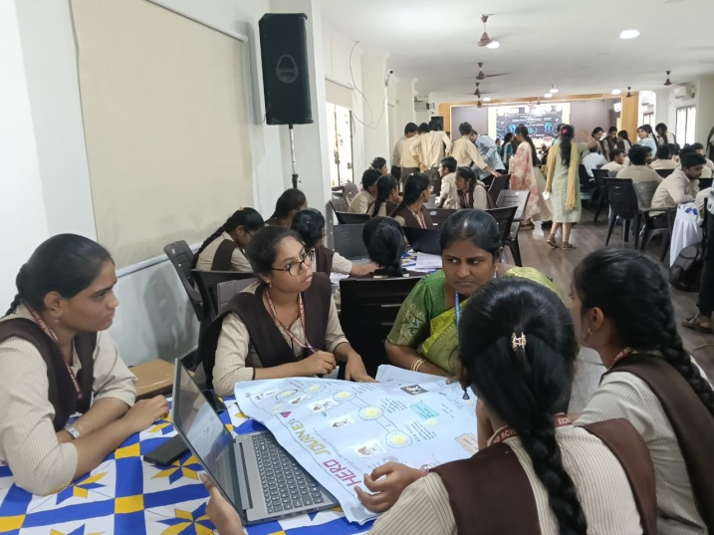 | 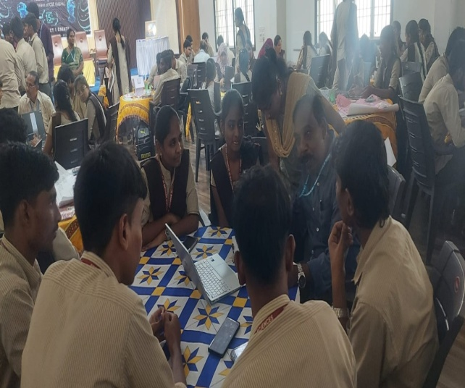
Exploring Ideas Through Collaborative Visualization | Team Discussion and Concept Refinement Session

